What explains why some countries experience greater cultural conflict than others

Name
Institution
Professor
Course
Date

Introduction
This paper will help to understand and explain why other countries experience greater conflict levels than others. The tested hypothesis stands a chance of being supported or not. This part of the study tries to explain and analyse the study to find out if there is any significant relationship between the hypothesises.

Research question
What explains why some countries experience greater cultural conflict than others?
The research hypothesis
- democratic countries are more likely to have cultural conflicts than dictatorship countries
- that the countries that experience wars are more likely to have cultural conflicts.
- More economically developed countries are less likely to have cultural conflicts than less economically developed countries.
- African and middle eastern countries have more cultural conflicts than the European and North America.
- the newly independent countries have the chance to have cultural conflict than the old independent countries

Research variables

Independent variables dependent variables
government cultural conflict
war
economic development
region

Hypothesis 1; democratic countries are more likely to have cultural conflicts than dictatorship countries
There is one variable in the above hypothesis which states that conflict is dependent on the type of government. Like in the case of the research, when the country has democratic leadership style, it is exposed to various conflicts within the country as compared to the dictatorship leadership style where they experience peace as a country (Trueba et al, 2014). Conflict issues arise because in the democratic country leaders have limited control over how individuals spend their time and how they choose to believe. People have the freedom to exercise various things like having many political parties. Having one leader that has control over everything that happens, the dictatorship countries live harmoniously (Trueba et al, 2014). Aspects of the government are tightly controlled, and meetings and groups might be banned or controlled. In this dictatorship governance, the rights of its citizens are disregarded and through police, force, spying and law people are controlled hence it becomes very difficult for conflicts to arise.
The levels of measurement used are ordinal for the dependent variables and nominal for the independent. The number of variables was a total of 677 where the independent variables were 332 while the dependent variables were 345. There was a strong significant relationship of conflict levels between the democratic country and the dictatorship country of prob= 0.000 when compared to the p-value of 0.05. The study found out that there were conflict issues in democratic countries as shown in the explanation above. Comparison between the government, the old democracy have the highest conflict which was none at 43.8% while the civil war at 6.7% and the autocratic at 8.3 have the lowest levels of conflicts.

Table 1

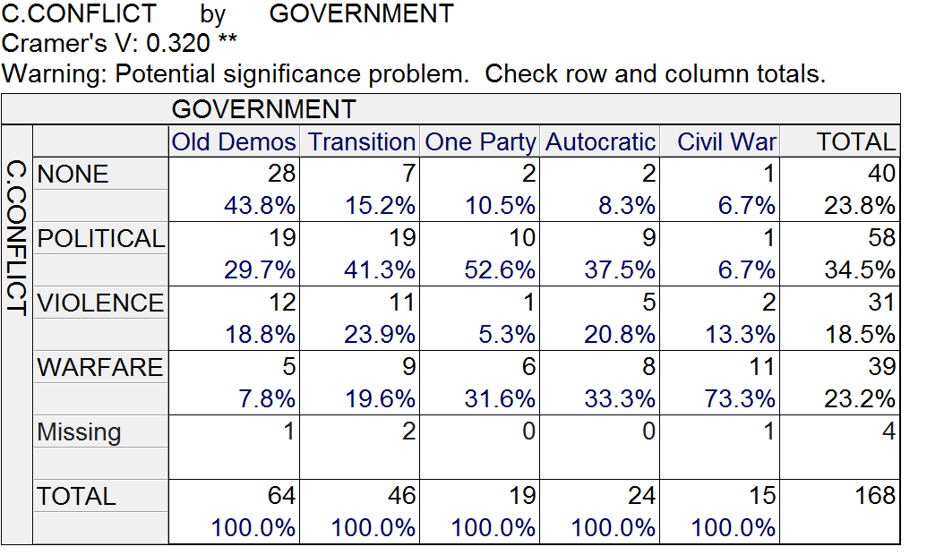
Figure 1 none conflict percent

Some studies conducted found out that violent conflict levels mostly war in the countries that are led democratically are significantly lower as compared to other state pairs. Democracy is not the cause of peace or cultural conflict but the interests of the nation, gender norms, and economic factors (Judd and Jacobs, 2015). Peace leads to the creation of democracy and there is emergent of democracy if the international environments are peaceful. When it comes to political conflicts, the democratic one has fewer cases as compared to one party (Judd and Jacobs, 2015). Despite that the democratic countries do not fight each other, reform of the democratic process can increase war cases. States that are democratizing that are recently changing to the democratic direction are greatly war-prone that the states that had already undergone the process.

The second hypothesis is that the countries that experience wars are more likely to have cultural conflicts.
The dependent variable was cultural conflict while the independent variables were war. This means that cultural conflicts depended on the war. War is not affected here, but the cultural conflicts keep on changing. Nominal and ordinal scales were the level of measurement used. The variable numbers used in both independent and dependent were 341 and 345 variables respectively. The level of statistical significance was the probability of 0.000. This showed a strong statistical significance when it is compared to the interpretation of the probability value of 0.005. This relationship showed that the countries that war have underlying cultural conflicts. Cramer’s V= 0.441 was the measure of association in the study. This measure of association was interpreted as very strong being above 0.30, weak was 0.10 to 0.19, moderate was 0.02 to 0.29 and very strong was 0.30 and above.
In the cross-tabulation, there is the dependent variables in the Row side and independent variables in the Column side, the column that we will be looking at is none in war and cultural conflict, countries with no war tend to have a high chance of non-cultural conflict. Follow by interstate countries.
There is a strong relationship between the cultural conflict level and countries that experience war. Statement of what is now known about the relationship: is a very strong relationship. Countries experience war do have high levels of cultural conflict. When we compare war and cultural conflict, the none had the highest percentage of having other conflicts when war arise at 34.5%
Table 2
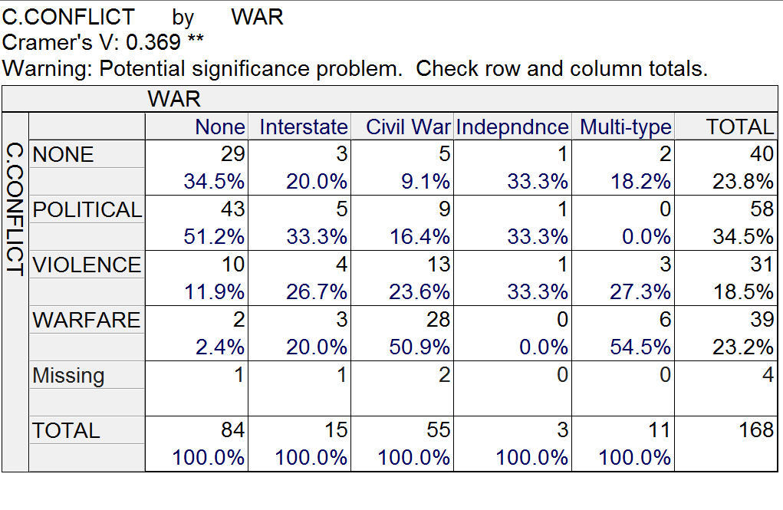

Figure 2

When there is a rise of war the cultural conflicts occur. Failure to attain the expectations of people of particular behaviors that comes from cultural backgrounds, it leads to cultural conflicts. And due to different beliefs, it is hard to resolve the cultural conflict (Trueba et al, 2014). Examples of this emerging conflicts are abortion debate and cleansing of ethnicity. Other than wars leading to cultural conflicts, also war can arise from cultural conflicts. The world waa r was much associated with the increase in cultural conflicts. When there is war, many issues arise that may make the war not to end easily, factors such as a religion, politics, and economy are leading issues during wars.
The third hypothesis is that the more economically developed countries are less likely to have cultural conflicts than less economically developed countries.
The independent variable used was economic development while the dependent variable was cultural conflict. The total number of variables used for the independent and dependent variables were 133 and 345 variables respectively. The measurement level used for both was ordinal. The statistical level was a probability of 0.000 at the end of the significance test. This was less than the value of probability interpretation which was a p-0.005. This shows that there is a strong relationship as the countries who had developed economically were less likely to have the cultural conflicts as compared to the countries that were less developed. The association measure termed as Gomma was equal to 0.373. The value of measure was interpreted as over 0.30 is strong, 0.20 to 0.29 was moderate, 0.10 to 0.19 weak and below -1 was very weak. In the cross-tabulation, there are the dependent variables in the Row side which is cultural Conflict and independent in the column side which is Economic Developed, the column that we will be looking at is none section where least developed countries have a low percentage of no cultural conflict than industrial and developing countries.
This hypothesis has been supported by the information from the study that highly industrialized countries have the least cultural conflict. This is because this country is so busy to make economic development thereby increasing their GDP. These countries are political, economically and socially stable hence they will have little things to fight over. Countries which are least developed pass through a phase of cultural conflicts where they face wars of various aspects and this also tend to lower the level of development. The least developed countries have a lower percentage of 14.6% of levels of low conflicts. Major shocks economically and geopolitically like the financial crisis in the global and the Arab spring, have left many countries at risk of drowning into conflict.

Table 3
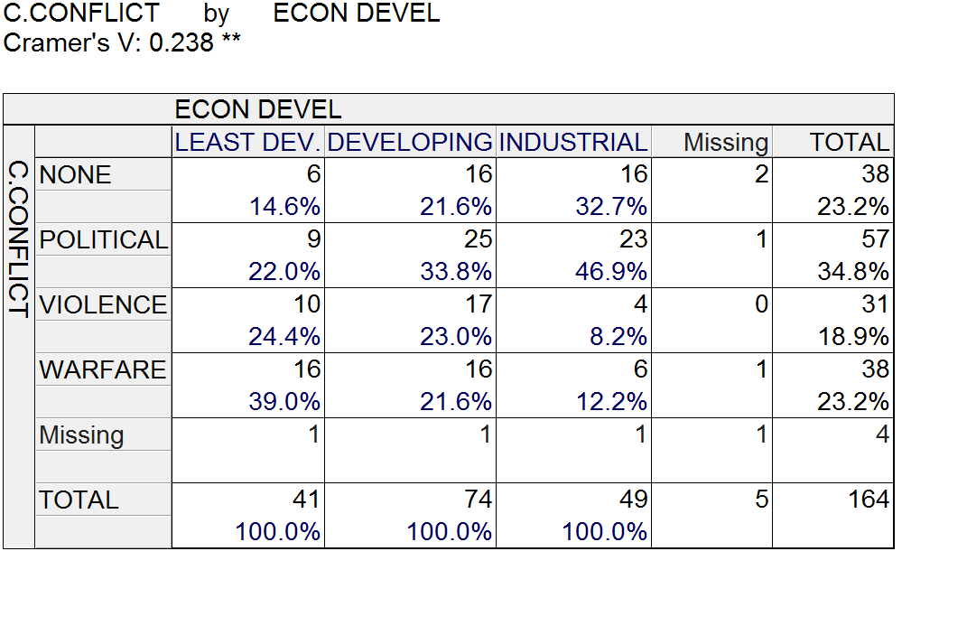
Figure 3

The fourth hypothesis was African and middle eastern countries have more cultural conflicts than the European and North America.
Ordinal and nominal were the level of measurement used with the variable numbers os 347 and 345. The cultural conflict depended on religion as the independent variables. The research findings were that the level of statistical significance probability was 0.000 which was a clear indication that the research was statistically significant as compared to the interpretation of the probability value of 0.05 as the p-value. The measure of association was Cramer's V= 0.769. The value of measure was interpreted as 0.30 and above strong, 0.20 to 0.29 was moderate, 0.10 to 0.19 weak and below one was very weak. In the cross-tabulation, there are the dependent variables in the Column side and independent variables in the Row side, the column that we will be looking at is none in both region and cultural conflict. The one column is showing that European and West. The European has the highest chances of non- cultural conflict while Africa and Mid East has the lowest. The hypothesis was highly supported because the Europeans and North America have the least cultural conflicts than the Africans and the middle east. Africa had 8.2%, the middle east had 7.7% while the European had 40.5%.

Table 4
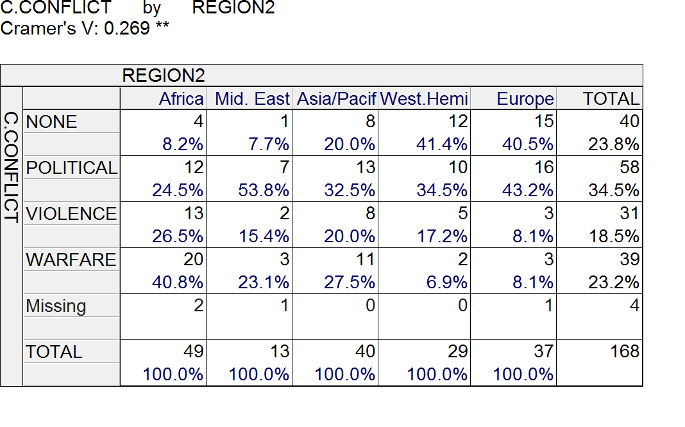
Figure four

Culture conflict was divided into two levels where the first level stated that the colonial education system and values of the westerns imposed on Africa as a general and Uganda as an individual were the leading causes of cultural conflict in Africa (Bornschier, 2015). The African religious leaders and the Christian missionary confrontation caused the religious conflict. The middle class was created by the colonial education system which at a higher rate become aware of the colonial subjugation and economic exploitation. The educated class became alienated from the masses after independence (Bornschier, 2015). Okot 1957, after his analysis of the cultural conflict, he identified that the root cause of the conflict was the education system that was imposed on the colonized people. Western values were acquired by those who went through the education system as they turned away from their cultural roots.
The fifth hypothesis was that the newly independent countries have a dreater chance to have cultural conflict than the old independent countries.
The independent variable was the independent period with the number of the variable of 339 while the dependent variable was a cultural conflict with 345 as the variable number. The level of measurement used was ordinal for both the dependent and the independent variables. The findings showed that there is a strong opposite relationship with the level of statistical significance of probability which is higher than p-value of 0.05 hence the results are not statistically significant. Gamma = 0.242 was the association measure. The measure of association was interpreted as; below one was very weak, 0.10 to 0.19 represented weak, 0.20 to 0.29 was a representation of moderate while 0.30 and above represented a very strong measure of association. Using the cross-tabulation, the dependent variables are on the low side while in the independent variables are shown in the column side. The column labeled none is our area of interest; it shows us that countries from 1819 to 1900 have no cultural conflicts and the year 1901 to 1944 has little cultural conflict than in the years from 1945 to 1989. The data output does support the hypothesis because there is a very strong relationship from the old to the new countries there has been reducing numbers of cultural conflicts because in the early days the cultural conflicts were stimulated by colonization hence the conflicts were high as compared to the recent years. This is shown through the changing nature in the data given.

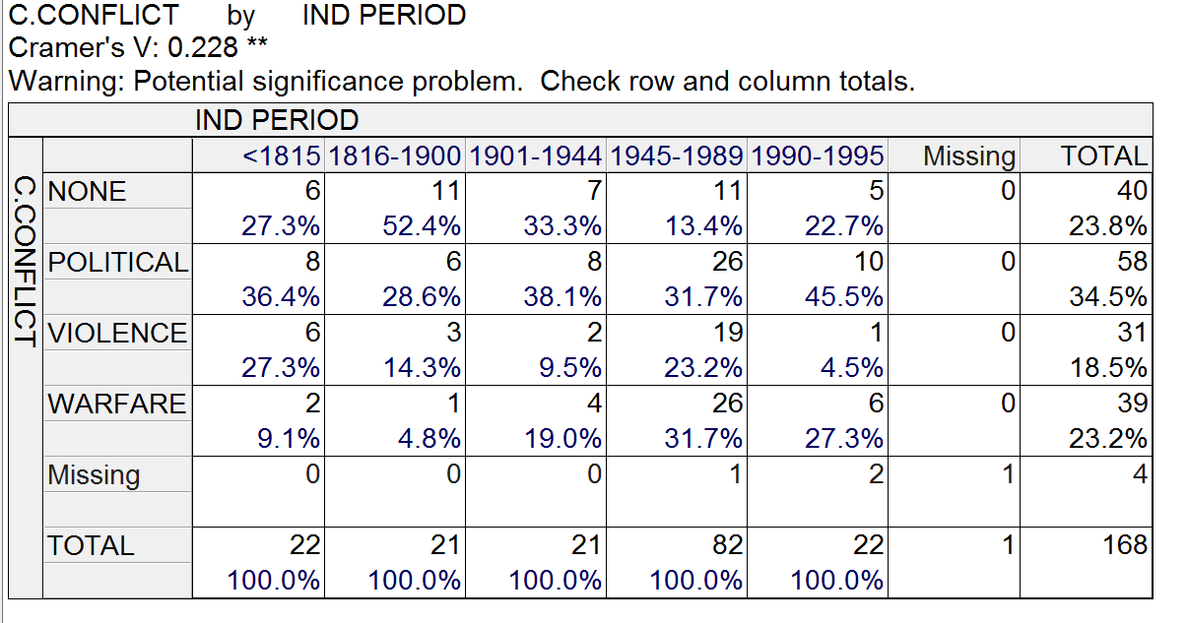

The percentage levels of cultural conflicts.

Conclusion
According to the findings above, the hypothesis was strongly supported. This shows that there was a significant relationship between the tested variables. the study found out that countries which were led by dictatorship had less cultural conflicts as compared to the democratic countries. Also that cultural conflict was likely to occur in countries which were in constant wars. Compared to the more economically developed countries, the countries that were less developed experiences cultural conflicts. Compared to Europe and north America. Africa and middle eastern also experienced cultural conflicts.

References
Bornschier, S. (2015). The new cultural conflict, polarization, and representation in the Swiss party system, 1975–2011. Swiss Political Science Review, 21(4), 680-701.
Judd, D. R., & Witt, S. L. (2015). Cities, Sagebrush, and Solitude: Urbanization and Cultural Conflict in the Great Basin. University of Nevada Press.
Trueba, H. T., Jacobs, L., & Kirton, E. (2014). Cultural Conflict & Adaptation. Routledge.

